**Name:** Zoe Defeo

**Date Created:** 6/29/2025

**Program Description:** This program prompts the user to enter a paragraph. The program then counts and displays each individual sentence.

**Functions Used in the Program:**

***#1***

**Function Name:** count(paragraph)

**Description:** Calculates the remaining number of tickets by subtracting the amount bought according to the user's input.

**Parameters:**

* paragraph(string) - The paragraph of text the user will input

**Variables:**

* sentences(list) - Scans the users paragraph for each sentence in it and adds it to the list.

**Logical Steps:**

1. Scan the user paragraph for individual sentences.
2. Return list of sentences.

**Returns:** sentences(list) - List of individual sentences in user paragraph.

***#2***

**Function Name:** main()

**Description:** Prompts the user to type out a paragraph, then scans it to determine how many individual sentences there are. The total sentence count and each sentence is then displayed.

**Parameters:** None

**Variables:**

* paragraph(string) - The paragraph of text the user will input
* total(list) - List of individual sentences returned by the count function.

**Logical Steps:**

1. Prompt user to type a paragraph
2. Paragraph is scanned to determine how many individual sentences there are.
3. Number of sentences are counted and displayed
4. Each individual sentence is printed.

**Returns:** None

**Logical Steps:**

1. Call the main() function
2. The count() function is called within the main() function

**Link to Repository:** <https://github.com/Zoe-Defeo/COP2373>

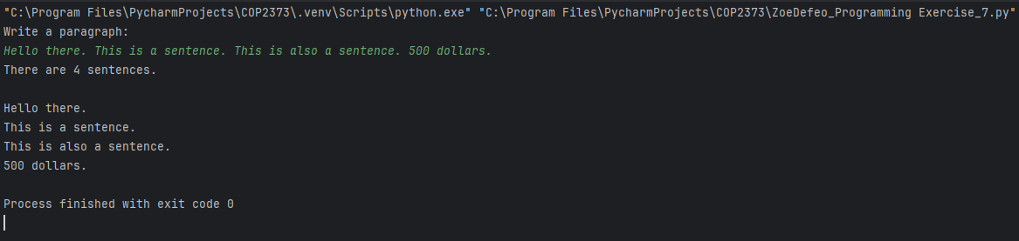**Output Screenshot:**